Canadian Union of Public Employees
CUPE Local 8443
Saskatoon Public Schools
Scholarships

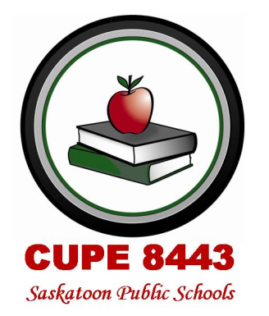

CUPE Local 8443 recognizes the value and the need for post-secondary education for students.

SCHOLARSHIP FORMAT

Two individual $1000 Scholarships are awarded to ANY Saskatoon Public Schools student, with the stipulation that the scholarship must be used to attend a trade or technical institute.

Four individual $1000 Scholarships awarded to ANY child or grandchild of a current CUPE 8443 member, to attend a post-secondary institution.

One individual $1000 Scholarship awarded to ANY current CUPE 8443 member returning to a post-secondary institute to upgrade their education.

CRITERIA

Applications must be completed and
returned to the CUPE Local 8443
Scholarship Committee before
September 30th.

Scholarship Committee
CUPE Local 8443 Saskatoon Public Schools
310-21st Street East
Saskatoon, SK S7K 1M7

Each application will include
1) an original 1 page (500- word) essay on “Unions/Unionism”.
2) school/community involvement
3) academic standing
4) proof of enrolment

For More information or an application form please see our website http://8443.cupe.ca/

CUPE Local 8443 hopes these scholarships will promote unionism among members and the general public.

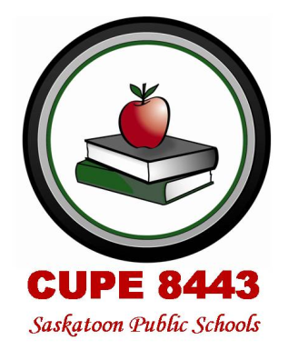
CUPE Local 8443 members work in a wide range of jobs at many locations.
We are the support workers for Saskatoon Public Schools.

