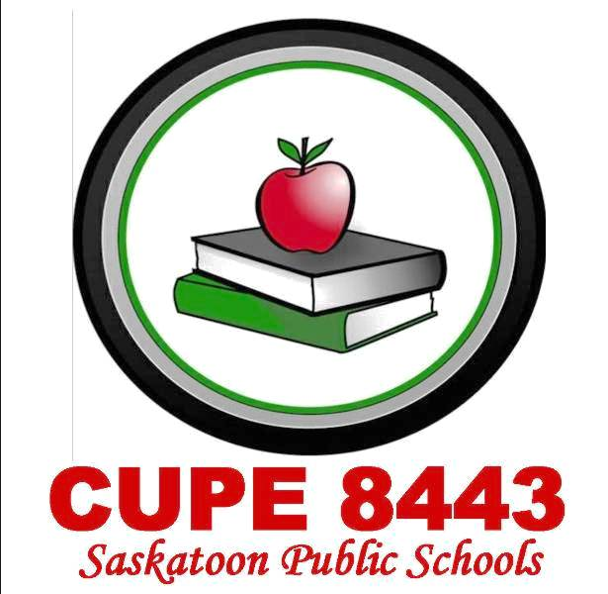
General Meeting Agenda
Date: December 4 2019 Location: Mount Royal
Sign In
Call to order – Scott Barrett
CUPE National Rep – Val Harvey
Welcome to Treaty 6 Territory in the Homeland of the Metis Nation
Adoption of Agenda –
Reading of the Equality Statement (Clayton)
New Members:
Roll call of officers (Carole-Anne)
Minutes of previous meeting – Date: November 2, 2019(Carole-Anne)
Matters arising out of minutes -
Secretary-Treasurer’s Report (Mark)
Correspondence –
- CUPE Saskatchewan- CUPE Saskatchewan Convention March 4-6, 2020 Saskatoon
- SFL- Summer Camp, Labour Training

President’s Report – Scott Barrett

Reports of committees – reports printed as submitted

- VP Chief Shop steward (Donna)
- VP Communication – (Dene)
- Education Committee (Vacant)
- Labour Management (Scott)
- Occ. Health & Safety (Larry)
- Pension and Benefits (Alex)
- Scholarship Committee (Nicole)
- Social Committee (Marcia)
- Bargaining/Negotiation- Scott
- CUPE Sask Environment Comm. – (Scott)

Reports from Delegates and Educational’s –
- Aboriginal Conference- Nicole Tran

Unfinished Business
- SAEL Meeting
- Maintenance Hours Of Work

New Business
- CUPE Winter School- One spot still open

Tuition Assistance

Questions and Information

Good of the Union – Contact Wendy Beckstrand

Adjournment

Next General Meeting: Date: January 11 2020 Location: Walter Murray Time: 10 am

