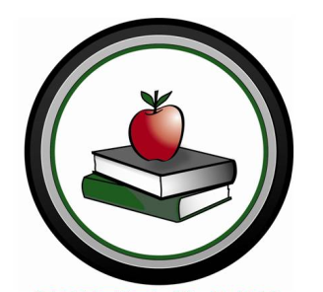
Local 8443 Scholarships
Canadian Union of Public Employees
Saskatoon Public Schools

CUPE Local 8443 members work in a wide range of jobs at many locations as support staff for Saskatoon Public Schools.

We recognize the value and the need for post-secondary education for students.

Our hope is these scholarships will promote unionism among members and the general public.

SCHOLARSHIPS
Two individual $1000 scholarships are awarded to ANY Saskatoon Public Schools student, with the stipulation that the scholarship must be used to attend a trade or technical institute.

Four individual $1000 scholarships awarded to ANY child or grandchild of a current CUPE 8443 member, to attend a post-secondary institution.

One individual $1000 scholarship awarded to ANY current CUPE 8443 member returning to a post-secondary institute to upgrade their education.

CRITERIA

Applications must be completed and
returned to the CUPE Local 8443
Scholarship Committee before
September 30th.

Scholarship Committee
CUPE Local 8443 Saskatoon Public Schools
#1007 – 201 21st Street E
Saskatoon, SK S7K 0B8

Each application should include:
- an original (500-word) essay on “Unions/Unionism”
- school/community involvement
- proof of enrolment
- academic standing

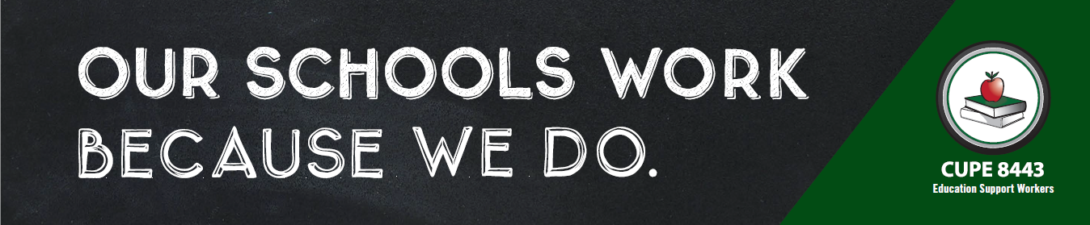
For more information or an application form please see our website http://8443.cupe.ca/

